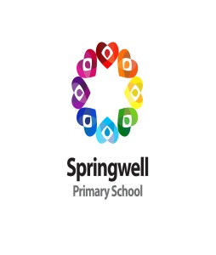**Autumn 1 Spellings**

|  |  |  |  |
| --- | --- | --- | --- |
| **Stage 1**  **‘ow’ sound**  Test date: 10/09/24 | **Stage 2**  **‘u’ sound**  Test date: 17/09/24 | **Stage 3**  **‘i’ sound**  Test date: 24/09/24 | **Stage 4**  **‘sure’ ending**  Test date: 01/10/24 |
| mouth  around  sprout  sound  spout  ouch  hound  trout  found  proud | touch  double  country  trouble  young  cousin  enough  couple  encourage  flourish | gym  myth  Egypt  pyramid  mystery  symbol  synonym  lyrics  system  gymnastics | measure  treasure  pleasure  enclosure  pressure  composure  leisure  exposure  closure  disclosure |
| Score: | Score: | Score: | Score: |
| **Stage 5**  **‘ture’ ending**  Test date: 08/10/24 | **Stage 6**  **challenge words**  Test date: 15/10/24 | **Stage 7**  **‘re’ prefix**  Test date: 22/10/24 |  |
| creature  furniture  picture  nature  adventure  capture  future  sculpture  fracture  mixture | actual  answer  bicycle  circle  earth  enough  fruit  island  often  popular | redo  refresh  return  reappear  redecorate  revenge  review  replay  reaction  rebound |
| Score: | Score: | Score: |
| Spellings I would like to work on next half term: | | | |