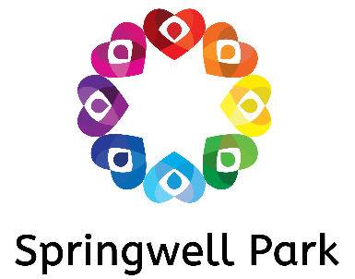

***Headteacher: Miss T Webley***

***Springwell Park Primary School***

***Menai Road · Bootle · L20 6PG***

***Tel: (0151) 288 6054 / 56 · Fax: (0151) 922 4517***

[***admin.springwellpark@schools.sefton.gov.uk***](mailto:admin.springwellpark@schools.sefton.gov.uk)

Dear parent/carer,

As I am sure you are aware, our children learn to read at Springwell Park through a phonics scheme called Read Write Inc. Read Write Inc, just like every other validated phonics scheme, has phonetically decodable storybooks in order to help accelerate your child’s progress. **Phonetically decodable storybooks are an essential part of the curriculum** because it means the stories are decodable to your child (they contain sounds in that your child has already learnt, therefore they can read them with a degree of independence).

**Research shows that children who are still accessing phonics sessions learn best with decodable books.** Think of it like this – you are given a book that contains both English and French. You will be able to read the English words because you have been taught them, but unless you are fluent in French, you will struggle with the French words. If a child is a given a book that isn’t matched to their phonetic ability, they will struggle with the words containing untaught sounds.

With this in mind, and as stated in the Department for Education Reading Framework, the **children who are being taught phonics will be bringing home their phonetically decodable storybook and corresponding book bag book** as home readers, as opposed to the Oxford Reading Tree colour banded system.

The children will read the Read Write Inc storybook three times in their phonics group with their partner. Re-reading the same book helps children to become confident readers. Each time they re-read, they build their fluency and comprehension. The fact that they can phonetically decode the words makes the children develop a love of reading and enthusiasm for the text. **On the third day, your child will take home that same book and enjoy showcasing their skills and knowledge to you – they will be able to read it to you like a storyteller.**

**In addition to the storybook, your child will also bring home a corresponding ‘book-bag’ book.** These are an optional extra that we have bought in to further help develop your child’s reading. The book-bag books are also phonetically decodable and match the storybook – for example, if your child has the storybook ‘Red hat Bob’ they would have the book-bag book ‘Black Hat Bob’. In addition to this, they will also have a Reading for Pleasure text that can be read by an adult to develop the love of reading. **In summary, your child will have three story books in their book-bags – the storybook, book-bag bag, and a reading for pleasure text.** These will be changed every three days.

**You may initially think that your child has regressed because their old colour banded book may seem more challenging. I can assure you that they haven’t and this isn’t the case at all. Following this approach will help accelerate your child’s progress, and once they have completed the phonics programme, they revert back to the colour banded system that they were on before. Please avoid saying ‘this book is too easy for you’ and instead say ‘I love how well you can read this book’. They are meant to be able to read all of the words as the book is the correct level.**

More detailed information will be offered during your ‘Meet the Teacher’ session. Thank you for your ongoing support.

Mr Hanlon and Mrs Boyham.